**Lab. Tutorial Module 3**

**In [1] :**

%matplotlib inline

import numpy as np

import matplotlib.pyplot as plt

from scipy import stats

# use seaborn plotting defaults

import seaborn as sns; sns.set()

**In[2]:**

from sklearn.datasets.samples_generator import make_blobs

X, y = make_blobs(n_samples=50, centers=2,

random_state=0, cluster_std=0.60)

plt.scatter(X[:, 0], X[:, 1], c=y, s=50, cmap='autumn');

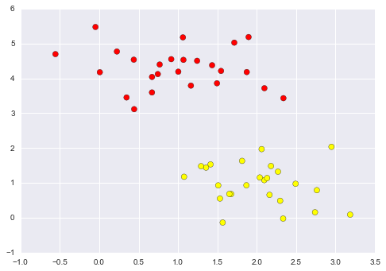

**In [3]:**

xfit = np.linspace(-1, 3.5)

plt.scatter(X[:, 0], X[:, 1], c=y, s=50, cmap='autumn')

plt.plot([0.6], [2.1], 'x', color='red', markeredgewidth=2, markersize=10)

for m, b in [(1, 0.65), (0.5, 1.6), (-0.2, 2.9)]:

plt.plot(xfit, m * xfit + b, '-k')

plt.xlim(-1, 3.5);

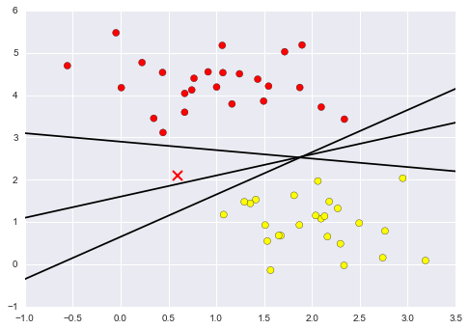

**In[4]:**

xfit = np.linspace(-1, 3.5)

plt.scatter(X[:, 0], X[:, 1], c=y, s=50, cmap='autumn')

for m, b, d in [(1, 0.65, 0.33), (0.5, 1.6, 0.55), (-0.2, 2.9, 0.2)]:

yfit = m * xfit + b

plt.plot(xfit, yfit, '-k')

plt.fill_between(xfit, yfit - d, yfit + d, edgecolor='none',

color='#AAAAAA', alpha=0.4)

plt.xlim(-1, 3.5);

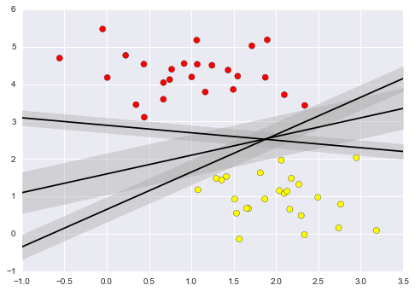

**In[5]:**

from sklearn.svm import SVC # "Support vector classifier"

model = SVC(kernel='linear', C=1E10)

model.fit(X, y)

**Out [5]:**

SVC(C=10000000000.0, cache_size=200, class_weight=None, coef0=0.0,

decision_function_shape=None, degree=3, gamma='auto', kernel='linear',

max_iter=-1, probability=False, random_state=None, shrinking=True,

tol=0.001, verbose=False)

**In[6]:**

def plot_svc_decision_function(model, ax=None, plot_support=True):

"""Plot the decision function for a 2D SVC"""

if ax is None:

ax = plt.gca()

xlim = ax.get_xlim()

ylim = ax.get_ylim()

# create grid to evaluate model

x = np.linspace(xlim[0], xlim[1], 30)

y = np.linspace(ylim[0], ylim[1], 30)

Y, X = np.meshgrid(y, x)

xy = np.vstack([X.ravel(), Y.ravel()]).T

P = model.decision_function(xy).reshape(X.shape)

# plot decision boundary and margins

ax.contour(X, Y, P, colors='k',

levels=[-1, 0, 1], alpha=0.5,

linestyles=['--', '-', '--'])

# plot support vectors

if plot_support:

ax.scatter(model.support_vectors_[:, 0],

model.support_vectors_[:, 1],

s=300, linewidth=1, facecolors='none');

ax.set_xlim(xlim)

ax.set_ylim(ylim)

**In[7]:**

plt.scatter(X[:, 0], X[:, 1], c=y, s=50, cmap='autumn')

plot_svc_decision_function(model);

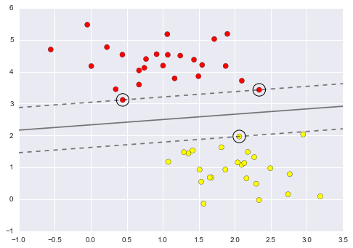

**In[8]:**

model.support_vectors_

**Out[8]:**

array([[ 0.44359863, 3.11530945],

[ 2.33812285, 3.43116792],

[ 2.06156753, 1.96918596]])

**In[9]:**

def plot_svm(N=10, ax=None):

X, y = make_blobs(n_samples=200, centers=2,

random_state=0, cluster_std=0.60)

X = X[:N]

y = y[:N]

model = SVC(kernel='linear', C=1E10)

model.fit(X, y)

ax = ax or plt.gca()

ax.scatter(X[:, 0], X[:, 1], c=y, s=50, cmap='autumn')

ax.set_xlim(-1, 4)

ax.set_ylim(-1, 6)

plot_svc_decision_function(model, ax)

fig, ax = plt.subplots(1, 2, figsize=(16, 6))

fig.subplots_adjust(left=0.0625, right=0.95, wspace=0.1)

for axi, N in zip(ax, [60, 120]):

plot_svm(N, axi)

axi.set_title('N = {0}'.format(N))

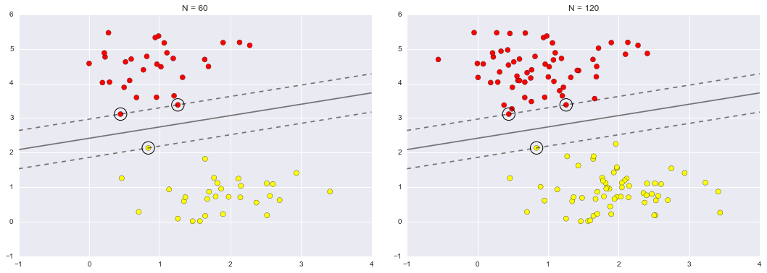

**In[10]:**

from ipywidgets import interact, fixed

interact(plot_svm, N=[10, 200], ax=fixed(None));

